

Министерство образования и науки

донецкой народной республики

Государственное образовательное учреждение

высшего профессионального образования

«донецкий национальный университет»

Физико-технический факультет

Кафедра компьютерных технологий

Лабораторная работа № 1

Студент: **Коробка Никита Алексеевич**

Донецк 2022

1. **Исходные данные:**

Таблица 1.1. – Исходные данные

|  |  |  |  |  |  |  |  |
| --- | --- | --- | --- | --- | --- | --- | --- |
| Name | Total | HP | Attack | Defense | Sp. Atk | Sp. Def | Speed |
| Bulbasaur | 318 | 45 | 49 | 49 | 65 | 65 | 45 |
| Ivysaur | 405 | 60 | 62 | 63 | 80 | 80 | 60 |
| Venusaur | 525 | 80 | 82 | 83 | 100 | 100 | 80 |
| VenusaurMega Venusaur | 625 | 80 | 100 | 123 | 122 | 120 | 80 |
| Charmander | 309 | 39 | 52 | 43 | 60 | 50 | 65 |
| Charmeleon | 405 | 58 | 64 | 58 | 80 | 65 | 80 |
| Charizard | 534 | 78 | 84 | 78 | 109 | 85 | 100 |
| CharizardMega Charizard X | 634 | 78 | 130 | 111 | 130 | 85 | 100 |
| CharizardMega Charizard Y | 634 | 78 | 104 | 78 | 159 | 115 | 100 |
| Squirtle | 314 | 44 | 48 | 65 | 50 | 64 | 43 |
| Wartortle | 405 | 59 | 63 | 80 | 65 | 80 | 58 |
| Blastoise | 530 | 79 | 83 | 100 | 85 | 105 | 78 |
| BlastoiseMega Blastoise | 630 | 79 | 103 | 120 | 135 | 115 | 78 |
| Caterpie | 195 | 45 | 30 | 35 | 20 | 20 | 45 |
| Metapod | 205 | 50 | 20 | 55 | 25 | 25 | 30 |
| Butterfree | 395 | 60 | 45 | 50 | 90 | 80 | 70 |
| Weedle | 195 | 40 | 35 | 30 | 20 | 20 | 50 |
| Kakuna | 205 | 45 | 25 | 50 | 25 | 25 | 35 |
| Beedrill | 395 | 65 | 90 | 40 | 45 | 80 | 75 |
| BeedrillMega Beedrill | 495 | 65 | 150 | 40 | 15 | 80 | 145 |
| Pidgey | 251 | 40 | 45 | 40 | 35 | 35 | 56 |
| Pidgeotto | 349 | 63 | 60 | 55 | 50 | 50 | 71 |
| Pidgeot | 479 | 83 | 80 | 75 | 70 | 70 | 101 |
| PidgeotMega Pidgeot | 579 | 83 | 80 | 80 | 135 | 80 | 121 |
| Rattata | 253 | 30 | 56 | 35 | 25 | 35 | 72 |
| Raticate | 413 | 55 | 81 | 60 | 50 | 70 | 97 |
| Spearow | 262 | 40 | 60 | 30 | 31 | 31 | 70 |
| Fearow | 442 | 65 | 90 | 65 | 61 | 61 | 100 |
| Ekans | 288 | 35 | 60 | 44 | 40 | 54 | 55 |
| Arbok | 438 | 60 | 85 | 69 | 65 | 79 | 80 |
| Pikachu | 320 | 35 | 55 | 40 | 50 | 50 | 90 |
| Raichu | 485 | 60 | 90 | 55 | 90 | 80 | 110 |
| Sandshrew | 300 | 50 | 75 | 85 | 20 | 30 | 40 |
| Sandslash | 450 | 75 | 100 | 110 | 45 | 55 | 65 |
| Nidoran♀ | 275 | 55 | 47 | 52 | 40 | 40 | 41 |
| Nidorina | 365 | 70 | 62 | 67 | 55 | 55 | 56 |
| Nidoqueen | 505 | 90 | 92 | 87 | 75 | 85 | 76 |
| Nidoran♂ | 273 | 46 | 57 | 40 | 40 | 40 | 50 |
| Nidorino | 365 | 61 | 72 | 57 | 55 | 55 | 65 |
| Nidoking | 505 | 81 | 102 | 77 | 85 | 75 | 85 |
| Clefairy | 323 | 70 | 45 | 48 | 60 | 65 | 35 |
| Clefable | 483 | 95 | 70 | 73 | 95 | 90 | 60 |
| Vulpix | 299 | 38 | 41 | 40 | 50 | 65 | 65 |
| Ninetales | 505 | 73 | 76 | 75 | 81 | 100 | 100 |
| Jigglypuff | 270 | 115 | 45 | 20 | 45 | 25 | 20 |
| Wigglytuff | 435 | 140 | 70 | 45 | 85 | 50 | 45 |
| Zubat | 245 | 40 | 45 | 35 | 30 | 40 | 55 |
| Golbat | 455 | 75 | 80 | 70 | 65 | 75 | 90 |
| Oddish | 320 | 45 | 50 | 55 | 75 | 65 | 30 |
| Gloom | 395 | 60 | 65 | 70 | 85 | 75 | 40 |
| Vileplume | 490 | 75 | 80 | 85 | 110 | 90 | 50 |
| Paras | 285 | 35 | 70 | 55 | 45 | 55 | 25 |
| Parasect | 405 | 60 | 95 | 80 | 60 | 80 | 30 |
| Venonat | 305 | 60 | 55 | 50 | 40 | 55 | 45 |
| Venomoth | 450 | 70 | 65 | 60 | 90 | 75 | 90 |
| Diglett | 265 | 10 | 55 | 25 | 35 | 45 | 95 |
| Dugtrio | 405 | 35 | 80 | 50 | 50 | 70 | 120 |
| Meowth | 290 | 40 | 45 | 35 | 40 | 40 | 90 |
| Persian | 440 | 65 | 70 | 60 | 65 | 65 | 115 |
| Psyduck | 320 | 50 | 52 | 48 | 65 | 50 | 55 |
| Golduck | 500 | 80 | 82 | 78 | 95 | 80 | 85 |
| Mankey | 305 | 40 | 80 | 35 | 35 | 45 | 70 |
| Primeape | 455 | 65 | 105 | 60 | 60 | 70 | 95 |
| Growlithe | 350 | 55 | 70 | 45 | 70 | 50 | 60 |
| Arcanine | 555 | 90 | 110 | 80 | 100 | 80 | 95 |
| Poliwag | 300 | 40 | 50 | 40 | 40 | 40 | 90 |
| Poliwhirl | 385 | 65 | 65 | 65 | 50 | 50 | 90 |
| Poliwrath | 510 | 90 | 95 | 95 | 70 | 90 | 70 |
| Abra | 310 | 25 | 20 | 15 | 105 | 55 | 90 |
| Kadabra | 400 | 40 | 35 | 30 | 120 | 70 | 105 |
| Alakazam | 500 | 55 | 50 | 45 | 135 | 95 | 120 |
| AlakazamMega Alakazam | 590 | 55 | 50 | 65 | 175 | 95 | 150 |
| Machop | 305 | 70 | 80 | 50 | 35 | 35 | 35 |
| Machoke | 405 | 80 | 100 | 70 | 50 | 60 | 45 |
| Machamp | 505 | 90 | 130 | 80 | 65 | 85 | 55 |
| Bellsprout | 300 | 50 | 75 | 35 | 70 | 30 | 40 |
| Weepinbell | 390 | 65 | 90 | 50 | 85 | 45 | 55 |
| Victreebel | 490 | 80 | 105 | 65 | 100 | 70 | 70 |
| Tentacool | 335 | 40 | 40 | 35 | 50 | 100 | 70 |
| Tentacruel | 515 | 80 | 70 | 65 | 80 | 120 | 100 |
| Geodude | 300 | 40 | 80 | 100 | 30 | 30 | 20 |
| Graveler | 390 | 55 | 95 | 115 | 45 | 45 | 35 |
| Golem | 495 | 80 | 120 | 130 | 55 | 65 | 45 |
| Ponyta | 410 | 50 | 85 | 55 | 65 | 65 | 90 |
| Rapidash | 500 | 65 | 100 | 70 | 80 | 80 | 105 |
| Slowpoke | 315 | 90 | 65 | 65 | 40 | 40 | 15 |
| Slowbro | 490 | 95 | 75 | 110 | 100 | 80 | 30 |
| SlowbroMega Slowbro | 590 | 95 | 75 | 180 | 130 | 80 | 30 |
| Magnemite | 325 | 25 | 35 | 70 | 95 | 55 | 45 |
| Magneton | 465 | 50 | 60 | 95 | 120 | 70 | 70 |
| Farfetch'd | 352 | 52 | 65 | 55 | 58 | 62 | 60 |
| Doduo | 310 | 35 | 85 | 45 | 35 | 35 | 75 |
| Dodrio | 460 | 60 | 110 | 70 | 60 | 60 | 100 |
| Seel | 325 | 65 | 45 | 55 | 45 | 70 | 45 |

1. **Таблица основных описательных статистических параметров (согласно п.12):**

Таблица 2.1. – Таблица основных описательных статистических параметров (1 часть)

|  |  |  |  |  |  |  |  |  |  |
| --- | --- | --- | --- | --- | --- | --- | --- | --- | --- |
|  | **Valid N** | **Mean** | **Confidence** | **Confidence** | **Median** | **Sum** | **Minimum** | **Maximum** | **Lower** |
| Name | 95 | 148,0000 | 142,3841 | 153,6159 | 148,0000 | 14060,00 | 101,0000 | 195,0000 | 124,0000 |
| Total | 95 | 395,4526 | 372,5085 | 418,3968 | 395,0000 | 37568,00 | 101,0000 | 634,0000 | 305,0000 |
| HP | 95 | 61,7684 | 57,4355 | 66,1013 | 60,0000 | 5868,00 | 10,0000 | 140,0000 | 45,0000 |
| Attack | 95 | 71,7895 | 66,6635 | 76,9155 | 70,0000 | 6820,00 | 20,0000 | 150,0000 | 52,0000 |
| Defense | 95 | 63,9158 | 58,4316 | 69,3999 | 60,0000 | 6072,00 | 15,0000 | 180,0000 | 45,0000 |
| Sp. Atk | 95 | 68,6000 | 61,8662 | 75,3338 | 65,0000 | 6517,00 | 15,0000 | 175,0000 | 45,0000 |
| Sp. Def | 95 | 64,9158 | 60,1375 | 69,6941 | 65,0000 | 6167,00 | 20,0000 | 120,0000 | 50,0000 |
| Speed | 95 | 69,7789 | 63,9724 | 75,5855 | 70,0000 | 6629,00 | 15,0000 | 150,0000 | 45,0000 |

Таблица 2.2. – Таблица основных описательных статистических параметров (2 часть)

|  |  |  |  |  |  |  |  |  |
| --- | --- | --- | --- | --- | --- | --- | --- | --- |
|  | **Upper** | **Variance** | **Std.Dev.** | **Standard** | **Skewness** | **Std.Err.** | **Kurtosis** | **Std.Err.** |
| Name | 172,0000 | 760,00 | 27,5681 | 2,82843 | 0,000000 | 0,247464 | -1,20000 | 0,490170 |
| Total | 490,0000 | 12685,80 | 112,6313 | 11,55572 | 0,097661 | 0,247464 | -0,45861 | 0,490170 |
| HP | 78,0000 | 452,41 | 21,2700 | 2,18226 | 0,541689 | 0,247464 | 1,02315 | 0,490170 |
| Attack | 90,0000 | 633,19 | 25,1633 | 2,58170 | 0,364928 | 0,247464 | 0,18728 | 0,490170 |
| Defense | 78,0000 | 724,76 | 26,9213 | 2,76207 | 1,239753 | 0,247464 | 2,86454 | 0,490170 |
| Sp. Atk | 90,0000 | 1092,69 | 33,0559 | 3,39146 | 0,826851 | 0,247464 | 0,46413 | 0,490170 |
| Sp. Def | 80,0000 | 550,21 | 23,4565 | 2,40658 | 0,177974 | 0,247464 | -0,39486 | 0,490170 |
| Speed | 90,0000 | 812,47 | 28,5039 | 2,92444 | 0,327428 | 0,247464 | -0,26384 | 0,490170 |

1. **Выводы, в которых необходимо указать, как влияют основные статистические параметры на анализ переменной (для любой переменной).**

*Valid N – число наблюдений;*

*Mean – среднее;*

*Sum – сумма;*

*Median - медиана;*

*Standard - Deviation – стандартное отклонение;*

*Variance - дисперсия;*

*Std. err. of mean - стандартная ошибка среднего;*

*conf. limits for means (95%) – 95% доверительные границы для среднего;*

*Minimum & maximum – Минимум и максимум;*

*Lower & Upper quartiles - нижние и верхние квартили;*

*Range - размах;*

*Quartile range – квартильный размах;*

*Skewness - ассиметрия;*

*Kurtosis - эксцесс;*

*Standard error of Skewness - стандартная ошибка ассиметрии;*

*Standard error of Kurtosis - стандартная ошибка эксцесса;*

1. **Таблица непараметрических статистических данных (согласно п.15).**

Таблица 4.1. – Таблица непараметрических статистических данных (1 часть)

|  |  |  |  |  |  |  |  |  |
| --- | --- | --- | --- | --- | --- | --- | --- | --- |
|  | **Mean** | **Valid N** | **Median** | **Mode** | **Frequency** | **Minimum** | **Maximum** | **25,000th** |
| Name | 148,0000 | 95 | 148,0000 | no mode |  | 101,0000 | 195,0000 | 124,0000 |
| Total | 395,4526 | 95 | 395,0000 | 405,0000 | 6 | 101,0000 | 634,0000 | 305,0000 |
| HP | 61,7684 | 95 | 60,0000 | 40,00000 | 10 | 10,0000 | 140,0000 | 45,0000 |
| Attack | 71,7895 | 95 | 70,0000 | 80,00000 | 8 | 20,0000 | 150,0000 | 52,0000 |
| Defense | 63,9158 | 95 | 60,0000 | 55,00000 | 8 | 15,0000 | 180,0000 | 45,0000 |
| Sp. Atk | 68,6000 | 95 | 65,0000 | 50,00000 | 9 | 15,0000 | 175,0000 | 45,0000 |
| Sp. Def | 64,9158 | 95 | 65,0000 | 80,00000 | 13 | 20,0000 | 120,0000 | 50,0000 |
| Speed | 69,7789 | 95 | 70,0000 | multiple |  | 15,0000 | 150,0000 | 45,0000 |

Таблица 4.2. – Таблица непараметрических статистических данных (2 часть)

|  |  |  |  |  |  |  |  |  |  |  |  |
| --- | --- | --- | --- | --- | --- | --- | --- | --- | --- | --- | --- |
|  | **75,000th** | **Geometric** | **Harmonic** | **Std.Dev.** | **Variance** | **Average** | **Range** | **Quartile** | **Skewness** | **Kurtosis** | **Sum** |
| Name | 172,0000 | 145,4000 | 142,7713 | 27,5681 | 760,00 | 23,74737 | 94,0000 | 48,0000 | 0,000000 | -1,20000 | 14060,00 |
| Total | 490,0000 | 378,1448 | 358,1916 | 112,6313 | 12685,80 | 93,36266 | 533,0000 | 185,0000 | 0,097661 | -0,45861 | 37568,00 |
| HP | 78,0000 | 57,8804 | 53,0871 | 21,2700 | 452,41 | 16,80399 | 130,0000 | 33,0000 | 0,541689 | 1,02315 | 5868,00 |
| Attack | 90,0000 | 67,0814 | 61,7734 | 25,1633 | 633,19 | 20,20388 | 130,0000 | 38,0000 | 0,364928 | 0,18728 | 6820,00 |
| Defense | 78,0000 | 58,7527 | 53,6303 | 26,9213 | 724,76 | 20,26748 | 165,0000 | 33,0000 | 1,239753 | 2,86454 | 6072,00 |
| Sp. Atk | 90,0000 | 60,8932 | 53,2682 | 33,0559 | 1092,69 | 26,37895 | 160,0000 | 45,0000 | 0,826851 | 0,46413 | 6517,00 |
| Sp. Def | 80,0000 | 60,2724 | 55,1208 | 23,4565 | 550,21 | 18,93429 | 100,0000 | 30,0000 | 0,177974 | -0,39486 | 6167,00 |
| Speed | 90,0000 | 63,4563 | 56,4472 | 28,5039 | 812,47 | 23,39058 | 135,0000 | 45,0000 | 0,327428 | -0,26384 | 6629,00 |

1. **Гистограммы, графики рассеяния:**

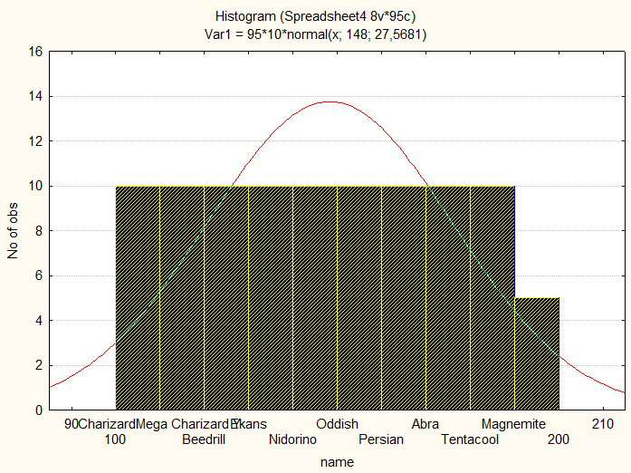

Рисунок 5.1 – Гистограмма "name"

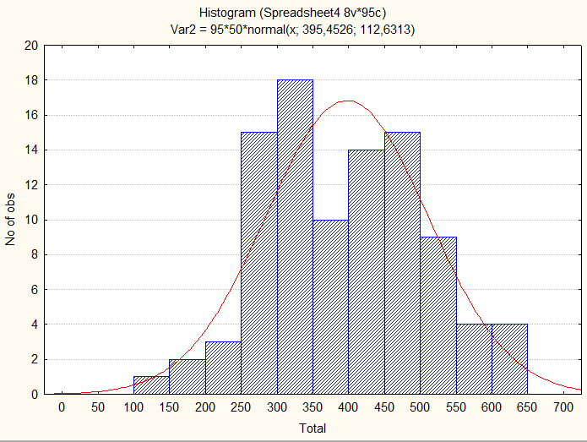

Рисунок 5.2 – Гистограмма “Total”

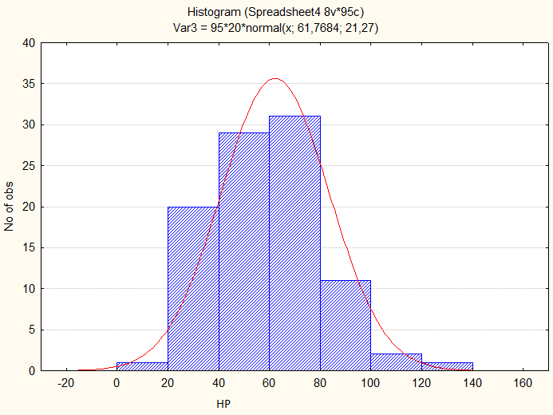

Рисунок 5.3 – Гистограмма “HP”

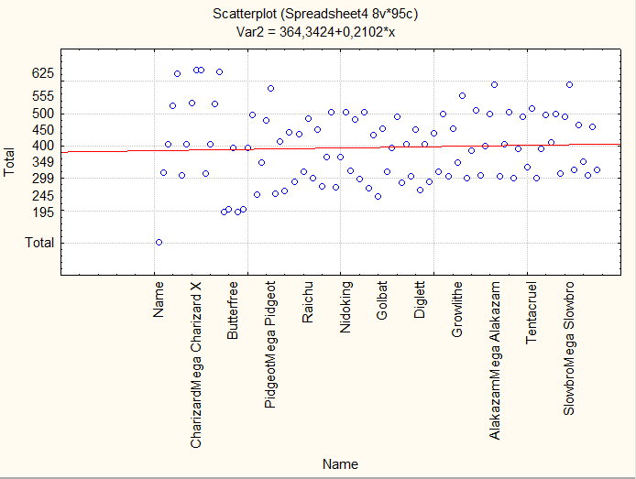

Рисунок 5.4 – График зависимости между Name и Total

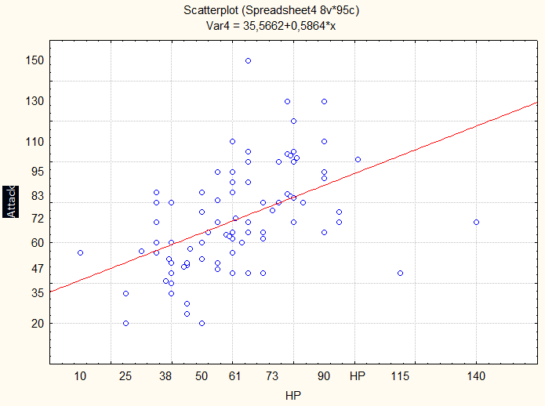

Рисунок 5.5 – График зависимости между HP и Attack

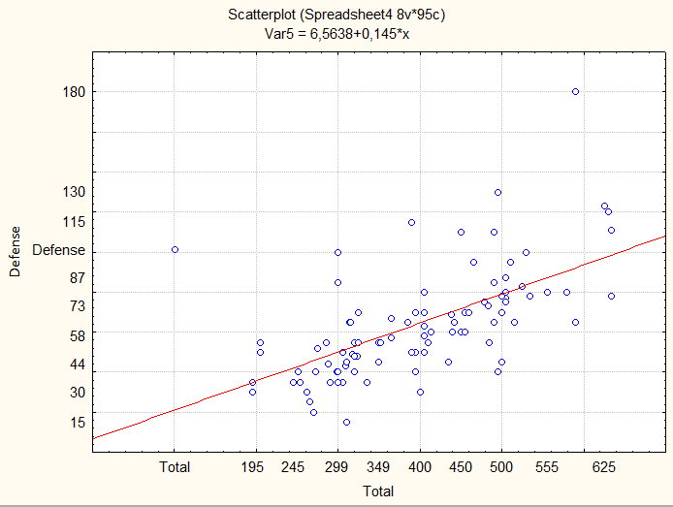

Рисунок 5.6 – График зависимости между Total и Defense

1. **Общие выводы по работе.**

В результате выполнения работы были закреплены теоретические сведения по статистическому оцениванию параметров распределений и получены практические навыки по определению основных выборочных характеристик при анализе данных с использованием прикладного программного обеспечения STATISTICA 6.0.